|  |
| --- |
| Enterprise Resource Planning (ERP) |
| Human Resource Management Systems (HRMS) |
| PREPARED BY: KG ERP Team |

Table of Contents

1 Objective 3

2 Human Resource Management System (HRMS) 3

3 Features of HRMS using Diagram 4

4 Requirement Specification 4

5 Functional Requirement 6

5.1 Terminology 6

6 Action Points: 7

6.1 HR/Admin Dashboard: 9

6.2 Login Page: 11

6.3 Employee Information: 15

6.4 Absence and Leave Information: 16

6.5 Time and Attendance: 18

6.6 Time approval 20

6.7 Reports: 21

6.8 Absenteeism calculation 21

7 Conclusion 23

# Objective

ERP (Enterprise Resource Planning) is a suite of integrated business software applications (often called modules) that allow companies to track and manage data and even automate some business functions, including inventory management. Here easy to setup, very easy to browse through master data, quickly find any information, easy and intuitive interface, change the system as per requirement, grid reporting with customizable report writer and above all integrated with ERP of Krishibid Group.

# Human Resource Management System (HRMS)

Human Resource modules in particular are used to track different people-related functions, such as planning, payroll, administration, development, hiring, and more. Business services, like Standard Operating Procedures, job postings, news, forums, tracking of work hours, and benefits, automate the Salary management, statutory reporting, Leave management, performance evaluation and promotion of all employees, attendance management for salary calculation, Approval Process, Full and final settlement. The personnel management comprises of HR master-data, personnel, recruitment and salary administration. Time management includes shift planning, time recording, absence & leave management. This section comprises of training and event management, additional training determination and training assessment etc., can all be unified into one module, which makes overall management and decision-making easier. For example:

# Features of HRMS using Diagram

#### Fig: 01 Features of HRMS

# Requirement Specification

Requirements are primarily categorized as Functional requirement and Technical requirement for the ERP system that is to be implemented in the Bangla Link. Detail requirements are further categorized under specific functional and technical area. The HR concern person must put comment against each detail requirement to show whether their proposed solution complies with the requirement.

# Functional Requirement

Functional requirements are categorized according the following functional areas that are sought into the proposed solution.

## Terminology

|  |  |  |
| --- | --- | --- |
| **#** | **Acronym** | **Technical Area** |
| **1** | ERP | Enterprise Recourse Planning |
| **2** | HRMS | Human Resource Management System |
| **3** | PF | Provident Fund |
| **4** | HR | Human Resource |

# Action Points:

|  |  |  |
| --- | --- | --- |
| **SL** | **Task** | **Time (day)** |
| 1 | Login Page |  |
|  | Employee information |  |
|  | Employee File upload (Image, Certificate, signature) |  |
|  | Export employee Biodata |  |
|  | Employee log table for in h/s update using trigger |  |
| 2 | Employee ID auto generated and align duplicate ID in a continuous process |  |
| 3 | Employee Hierarchy process development |  |
| 4 | Basic form and data Validation |  |
| 5 | Time Approval process |  |
| 6 | Yearly Holiday Setup |  |
| 7 | Weekly monthly and yearly |  |
| 8 | Employee attendance with date range |  |
| 9 | Read attendance from punch machine |  |
| 10 | attendance process and execution (using service) |  |
| 11 | Leave policy setup |  |
| 12 | Leave apply |  |
| 13 | Leave application list |  |
| 14 | Leave status |  |
| 15 | Leave Approval system |  |
| 16 | Leave Approval list |  |
| 17 | Employee leave statistics |  |
| 18 | Leave At glance |  |
| 19 | Leave yearly Setup |  |
| 20 | Report Server Integration and deployment |  |
| 21 | DB Modification |  |
|  | Mock up UI design |  |
|  | Windows Service development and deployment |  |
|  | Performance Appraisal Plan |  |
|  | Travel Allowance |  |
|  | Requirement Process |  |
|  | Employee Training Process  Training setup  Training select Process |  |
|  | **Total Man day** |  |

## Employee, Manager & HR/Admin Dashboard:

Employee Dashboard

**After Login Individual User will display as below:**

* Current Attendance Status. If punch data not syn here will message not syn data yet
* Count Total Late in and Early out Status. User can see details which date S/He late in or early out
* Upcoming Event specially this week like collogues birthday
* Upcoming Govt Holiday
* Leave Balance/Status like total Leave consumed leave, Remaining leave with leave category
* In-Time Statistics Report with Pie/Graph chart for this month or date range
* Pending Task and task list with priority
* Provident Fund Balance

Line Manager Dashboard

* All the same as User Dashboard.
* Display Leave Application Request total count. After click total it will display in details employee wise.
* Additional All team member time status
  + All employee time will show
  + Individual Employee time will show with Employee ID and date range
* How many and who are on leave today.
* Employee trend like time, task completeness can be measure by line manager.

Admin/HR Manager Dashboard

All the same as User Dashboard and Line Manger Dashboard

Additional All employee time status

Total Employee

Total new joins

Total notice period

Total Present today

Total Absent

Total Late

Total Leave

Today Meeting

Upcoming event

Employee Gender view

Average Employee Tenure (in year)

Average Employee Age (in Year)

Today attendance on Graph / Pie Report by Company/Department wise

how many employees today leave. It will display company wise when click details

At a glance management can see some key features on dashboard page. As bellow:

|  |  |  |  |
| --- | --- | --- | --- |
| Total new joins (3) | Total notice period (3) | Total Employee (300) |  |
| Total Present (3) | Total Absent (3) | Total Late (3) | Total Leave (12) |
|  | Today Meeting (3) | Upcoming event (3) |  |

**Where total numbers will show after click on its detail will show.**

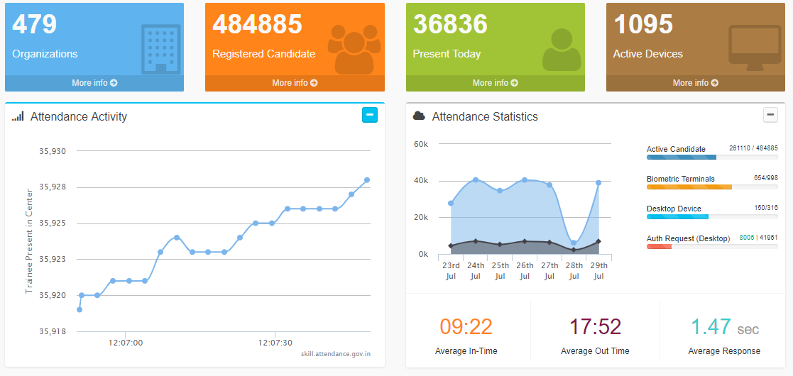

## Login Page:

Passwords are never stored in the plain text in any Application. It should be encrypted, so that no one can read it. it will develop using encrypted and decrypted.

Once some records are inserted into the SQL Server database, we will write a stored procedure to fetch the user information and validate the user information.

* Add Remember function
* Forgot Password
* Change Password
* Display User name like: Welcome Username
* Display User Profile Picture to Right Top Corner
* If a user name and password is valid, it is a successful login and redirects the user to the landing page. **User name will be Employee ID ex: KG3068 (must be Trim, no case sensitive, Password length minimum 4 char)**
* If a username does not exist in the database, it shows the error 'User Does not Exist'.
* If the user is a valid user and wrong password is given by the user, it will give the me
* Number of failed attempts.
* If failed attempt is more than or equal to 5 times, it will lock the user out.

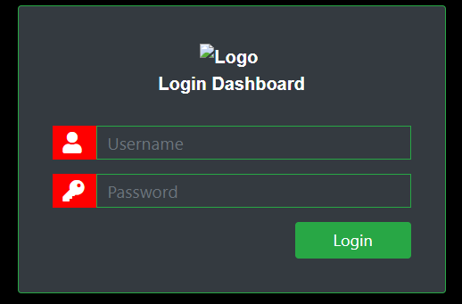

This login UI will be change based on better one

|  |  |
| --- | --- |
| Header  Welcome to: user | |
| HRMS  **Employee**  Employee Entry  Employee List  Export Biodata  Update Employee  Attendance  Attendance List  Attendance Process  Attendance Approval  Leave  Leave Apply  Leave Approved  Leave status/Balance  Time Approval  Modify Time App.  Modify Date App. | Total Department  Total Company  Total user 200  Upcoming Holiday  16-12-19 Victory Day  14-4-2010 Boishak  Leave Balance:  TL:20  AL: 4  CL: 5  Total Company Offfice |
| Footer | |

Note: **Employee Entry,** mean CRUD operation but not delete option. **Just user active inactive: Have option to export employee biodata**

## Employee Information:

Employee will be entry to system through employee form with necessary information/fields. Employees within the organization can easily access information related to notice board, leave status, company policies etc. They can apply for Leave online, can view their leave status, PF (Provident Fund) statements, and can also be viewed without having to wait for HR reverts. Thus, management spend less time answering questions and more time pursuing the vision.

* + Personal Employee Login.
  + Manage Leave Application.
  + Send leave application through email.
  + Email Receipt of Leave Approval.
  + Personal Dashboard.
  + Notice Board.
  + Image, signature upload
  + Auto ID generator
  + Export Biodata

## Absence and Leave Information:

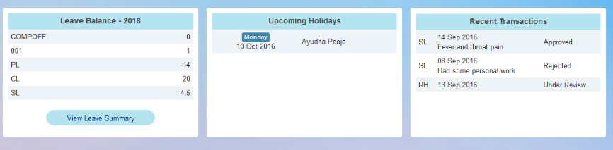

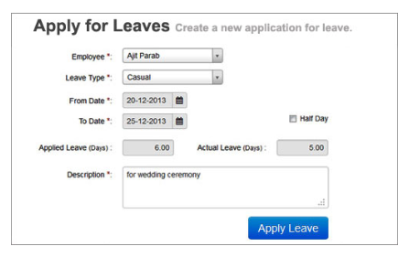

The system must provide for the performance of all activities associated with determination of proper leave balances for all types of leave. Employee Leave & Attendance Management System streamlines communication between HR and employees and facilitates simple yet efficient management of employee leave. Leave approval no longer involve trails of paperwork. The system provides full audit trails of management staff's leave balances and plans. Management just need to enter the dates on which an employee has availed leave and the types of leave availed. Based on the rules defined in the masters while setting up exactly HRMS, reports would be generated:

* + Highly configurable User Defined Leave Rules.
  + User Defines Approval Hierarchy.
  + Online leave requisition, Approvals and rejection.
  + E-Mail Notifications.
  + Leave Balance Details
  + Flexible Attendance Input
  + Monthly / Yearly leave carry forward & encashment.
  + Attendance data integration from any time – machine.

**Leave Type:** There are some kind of leave like as below:

* Privileged Leave/ Earned Leave
* Casual Leave
* Sick Leave
* Maternity Leave

Leave type can be add, modify using leave entry page.

**Leave Process:** After login individual employee can apply leave to her/his concerned line Manager. And will found email notification. Employee can see her/his leave status.

**Condition:**

1. User can see his/her consumed and remaining leave balance in top of Application Form.
2. After consumed all regular leave, he/she can apply leave without paid.
3. If line Manger approve in time then HR part will auto be approved
4. If employee fail to apply before consumed leave then he/she have to apply to Line manager. In this regards Line Manger and HR both have to approved leave separately. Otherwise it will not approve and will consider as without paid leave.
5. Employee can apply leave in define format to his/her line manger
   1. Apply Before consumed: it will approve by line manager and notify to HR
   2. Apply After Consumed: Both Line manager and HR have to approve then will approved otherwise rejected

## Time and Attendance:

The timings regularities and attendance etc., are the parts of this section. It keeps track of the employee attendance and keeps the data secured for the future reference. Some of the most important features this module provides are mentioned below.

**July 30, 2019-Ashraf In**

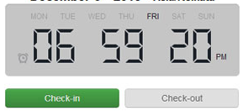

**July 30, 2019-Ashraf OUT**

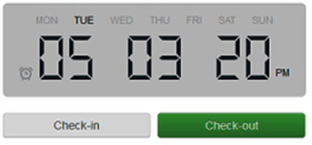

**Attendance mainly two types according to employee’s duties:**

1. Regular Base
   1. 9.00AM to 5.00PM (regular)
   2. 10.00AM to 6.00PM (daylight saving)
2. Roaster base
   1. 6.00AM to 2.00PM (Morning)
   2. 2.00PM to 8.00PM (Evening)
   3. 8.00PM to 6.00PM(Night)
   4. Special Type of shift

**Conditions:**

1. Here dashboard will show total employees, present employees, absent employees, where total late will count. Here also detail option when click in view then company/division wise will show.
2. Both attendance type will configurable by admin. It may change according to management decision.
3. Calendar appearance for better visualization of employee attendance
4. Application facilities for holidays and Short leaves
5. Attendance report will generate with monthly or yearly or date range
6. Have to option for tagging employee to above attendance type for duties if management want.
7. **Search attendance using Employee ID and date range**

## Time approval

Employee Time Approval Management System streamlines communication between Line Manager, HR and employees and facilitates simple yet efficient management of employee late coming due to field work, early going, absence due to travel on Duty. Time approval no longer involve trails of paperwork.

* Late Coming, Early going, Absence due to travel on Duty etc.
* Attendance can be modifying according to employee application to his/her line manager. If any employee has to out of office due to company’s purpose then S/He can apply to concern line Manager for approving it. If line manager approves that day will not late/early out.

## Reports:

1. Collect T&A data on a pay period basis, e.g., daily, weekly, biweekly, semimonthly, and/or monthly basis. Capture T&A data in days, fractions of hours, or other units of measure as required.
2. Management can see report date range wise.
3. Individually (Employee base) report have to generate with date range.
4. Company wise attendance report with date range

## Absenteeism calculation

**Absenteeism** is a habitual pattern of absence from a duty or obligation without good reason. Generally, absenteeism is unplanned absences. Absenteeism has been viewed as an indicator of poor individual performance, as well as a breach of an implicit contract between employee and employer. It is seen as a management problem, and framed in economic or quasi-economic terms. More recent scholarship seeks to understand absenteeism as an indicator of psychological, medical, or social adjustment to work.

If you feel like employees are frequently absent from work, you should calculate your absenteeism rate. So, how do you calculate employee absenteeism?

Use the absenteeism formula to calculate the percentage of absences in your small business:

**Absenteeism Rate** = (Average # of Employees X Missed Workdays) / (Average # of Employees X Total Workdays)

**Absenteeism rate example**

Take a look at the following example to further help you understand absenteeism calculations.

Let’s say you want to calculate the absenteeism rate for your business during October (2018).

1. First, find the average number of employees. At the beginning of October, you had seven employees. At the end of the month, you had nine. **Your average number of employees is 8 ([9 + 7] / 2).**

2. Secondly, calculate your total workdays in the period. Your business is open Monday – Friday. There were no holidays in October. **Your total number of workdays is 23.**

3. Next, find the number of workdays lost to absenteeism. Workdays are eight hours long in your business. One employee missed one day and another employee missed one day. In total, your employees were absent for two full days. Another employee was gone for an additional four hours. First, divide the four-hour day by eight hours to get 0.5. **Then, add 0.5 and 2 to get a total of 2.5 missed days.**

4. Plug your numbers into the absenteeism rate formula:

Absenteeism Rate = (8 X 2.5) / (8 X 23)

Absenteeism Rate = 20 / 184

**Absenteeism Rate = 0.11**

To turn your absenteeism rate into a percentage, multiply it by 100. Your absenteeism rate during October was approximately 11%.

The lower your absenteeism rate, the better. Absenteeism rates can vary by industry. As a general rule of thumb, you want to avoid having an absenteeism rate in double digits.

# Conclusion

Necessary attribute detail has been given based on the requirements and understanding from the user end. But IT Team must analyze and improvise if there needed more attributes and condition to manage the HRMS more efficiently in KG.